**Instructions for Boston Housing Example**

1. Navigate to <https://baruch.bigdatadev.pitneycloud.com/> and enter the credentials provided to you  
   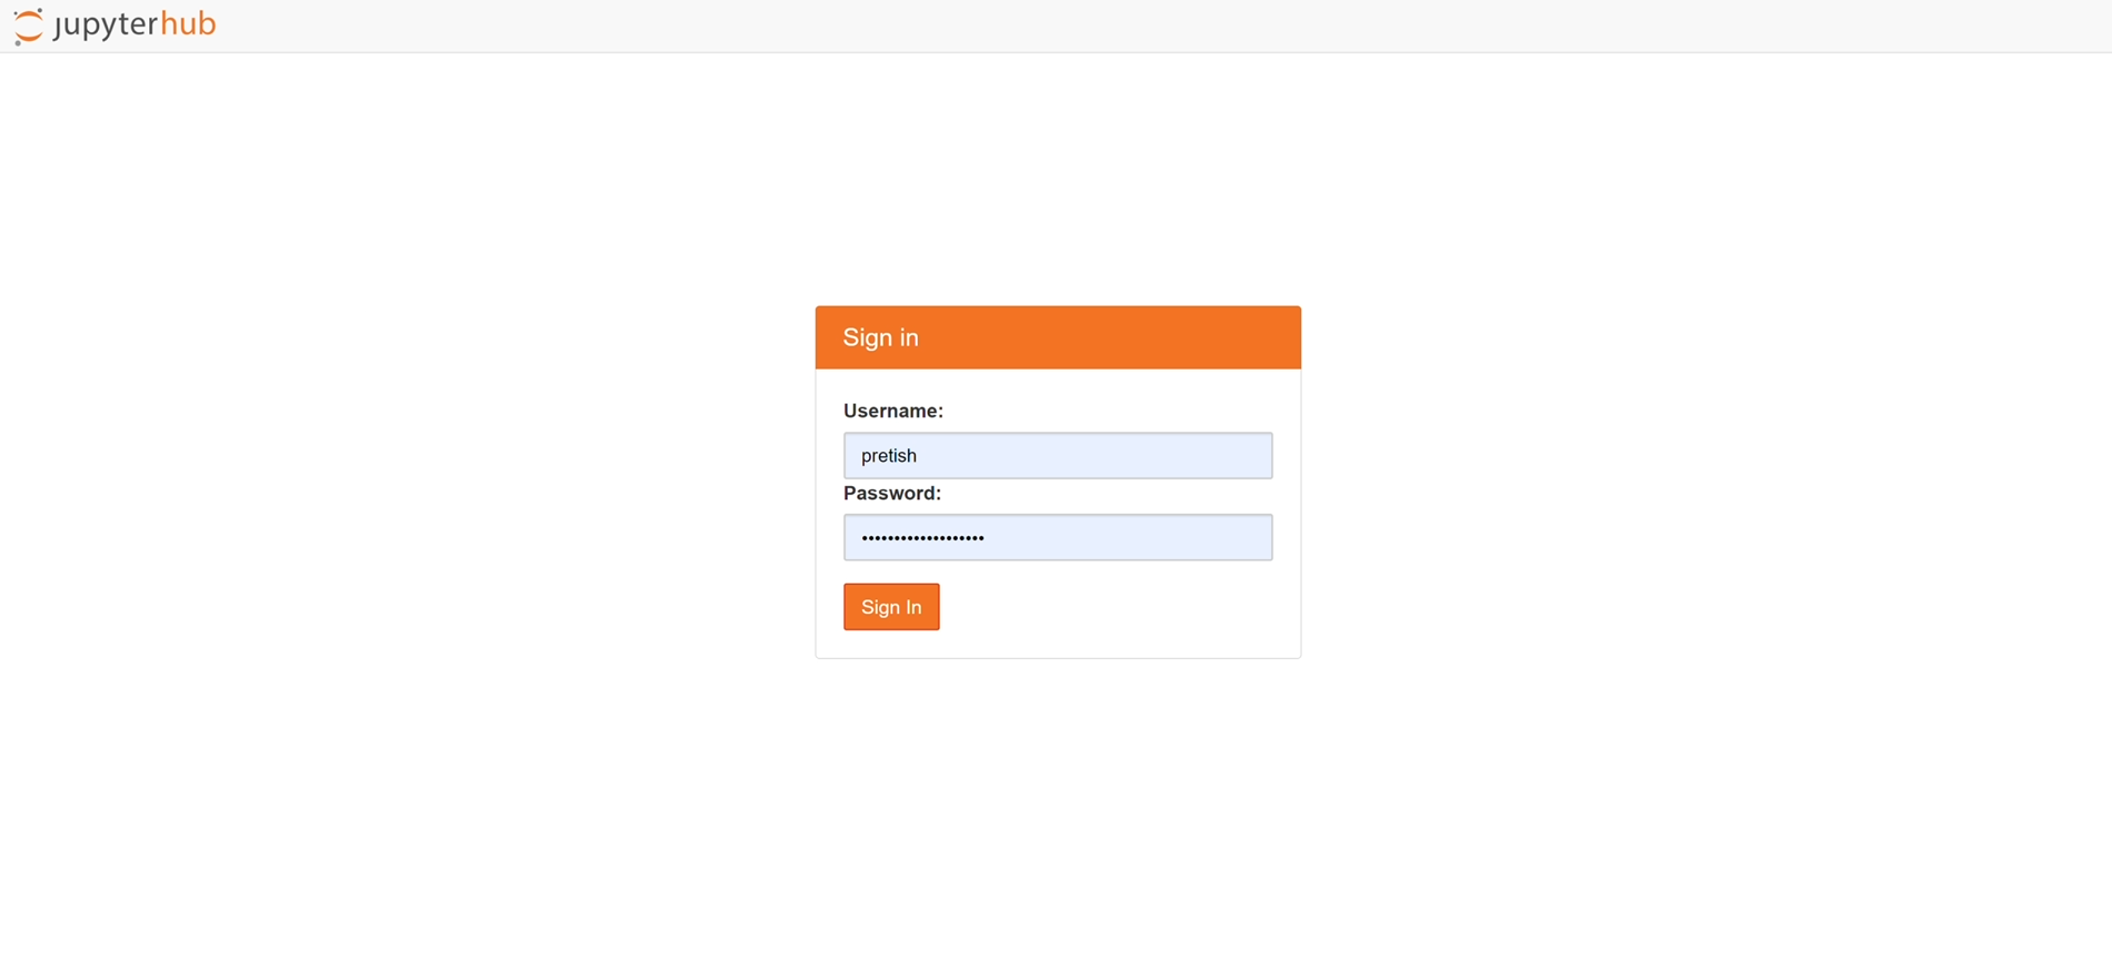
2. Select the appropriate computing resources that you need to run your code  
   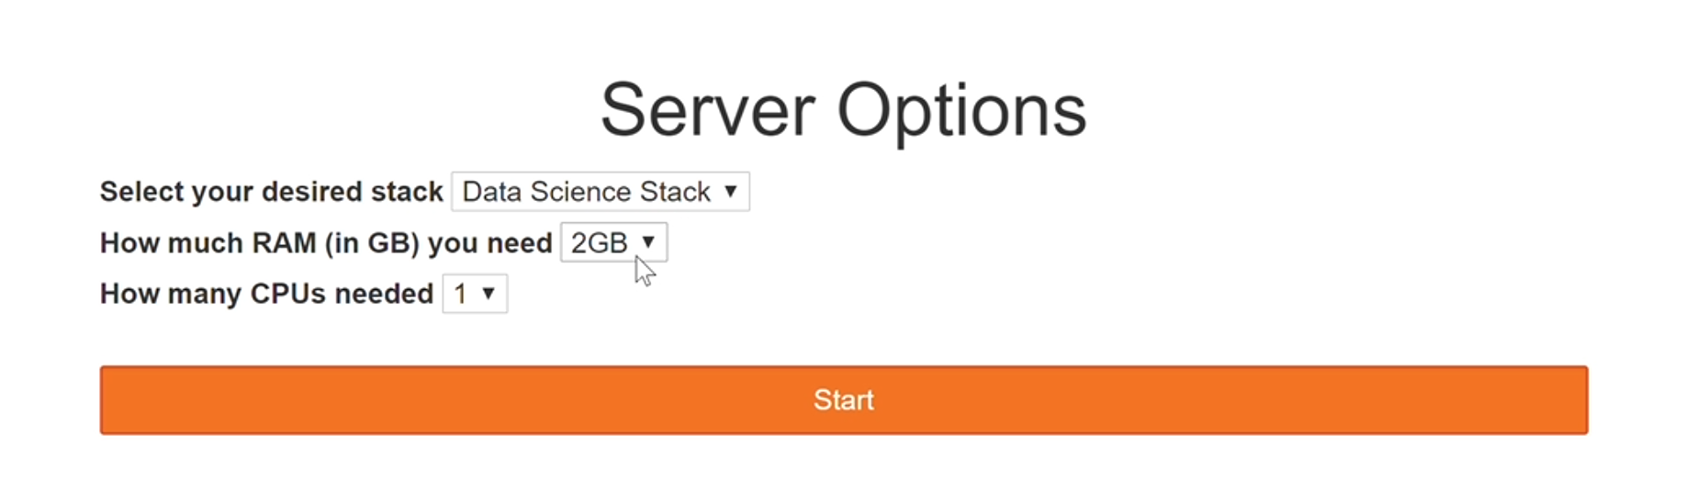
3. Go to the Examples Tab and click on the green ‘Use’ button for the Data Challenger v1.0 notebook which will then create a copy of the notebook in your repository.  
   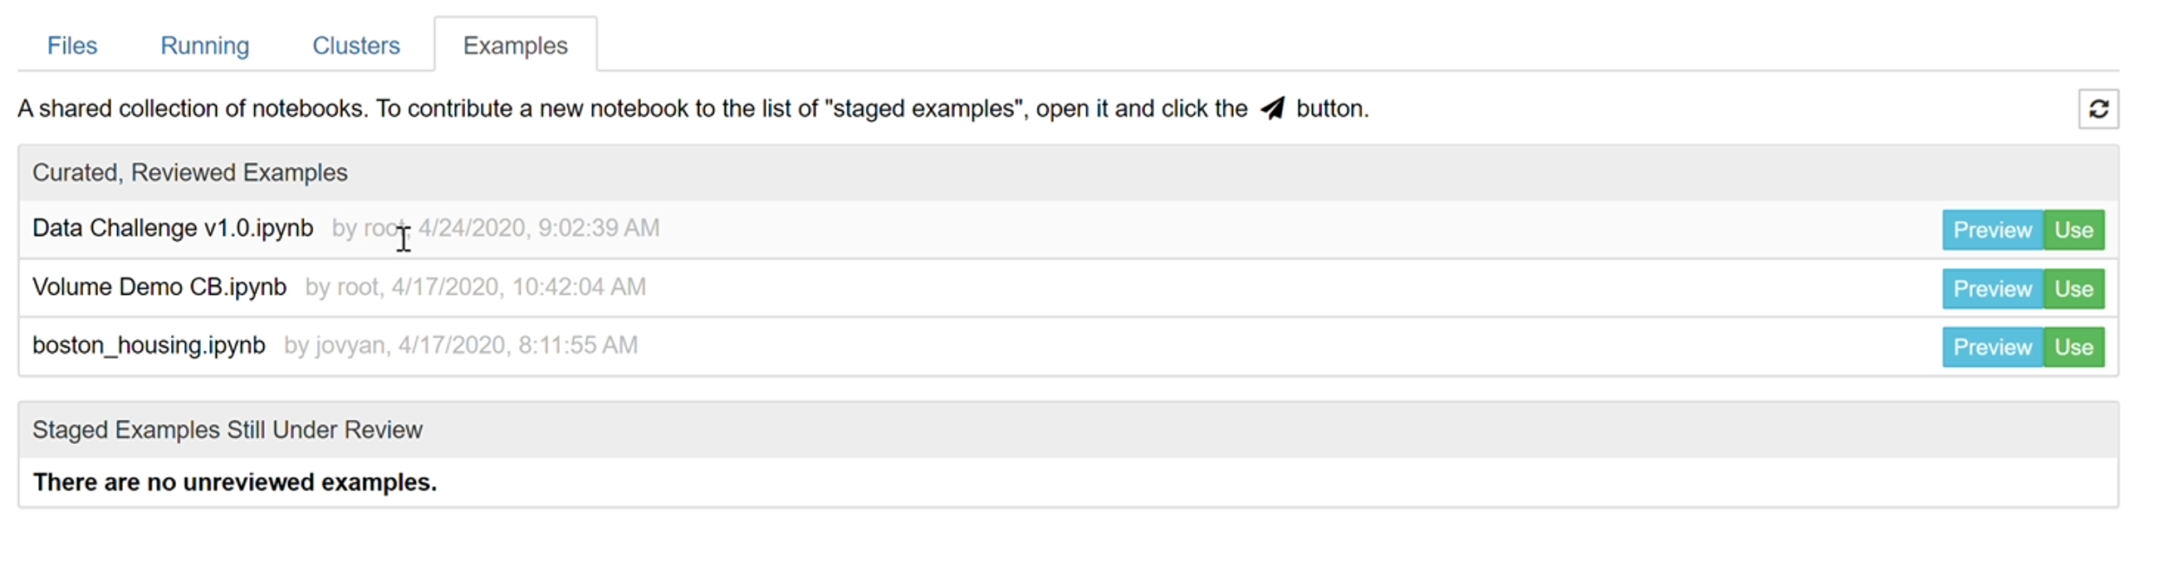
4. Go to Cell> Click Run All to see the output of all the code in the notebook  
   If you wish to run a particular cell of code click Ctrl+Enter  
   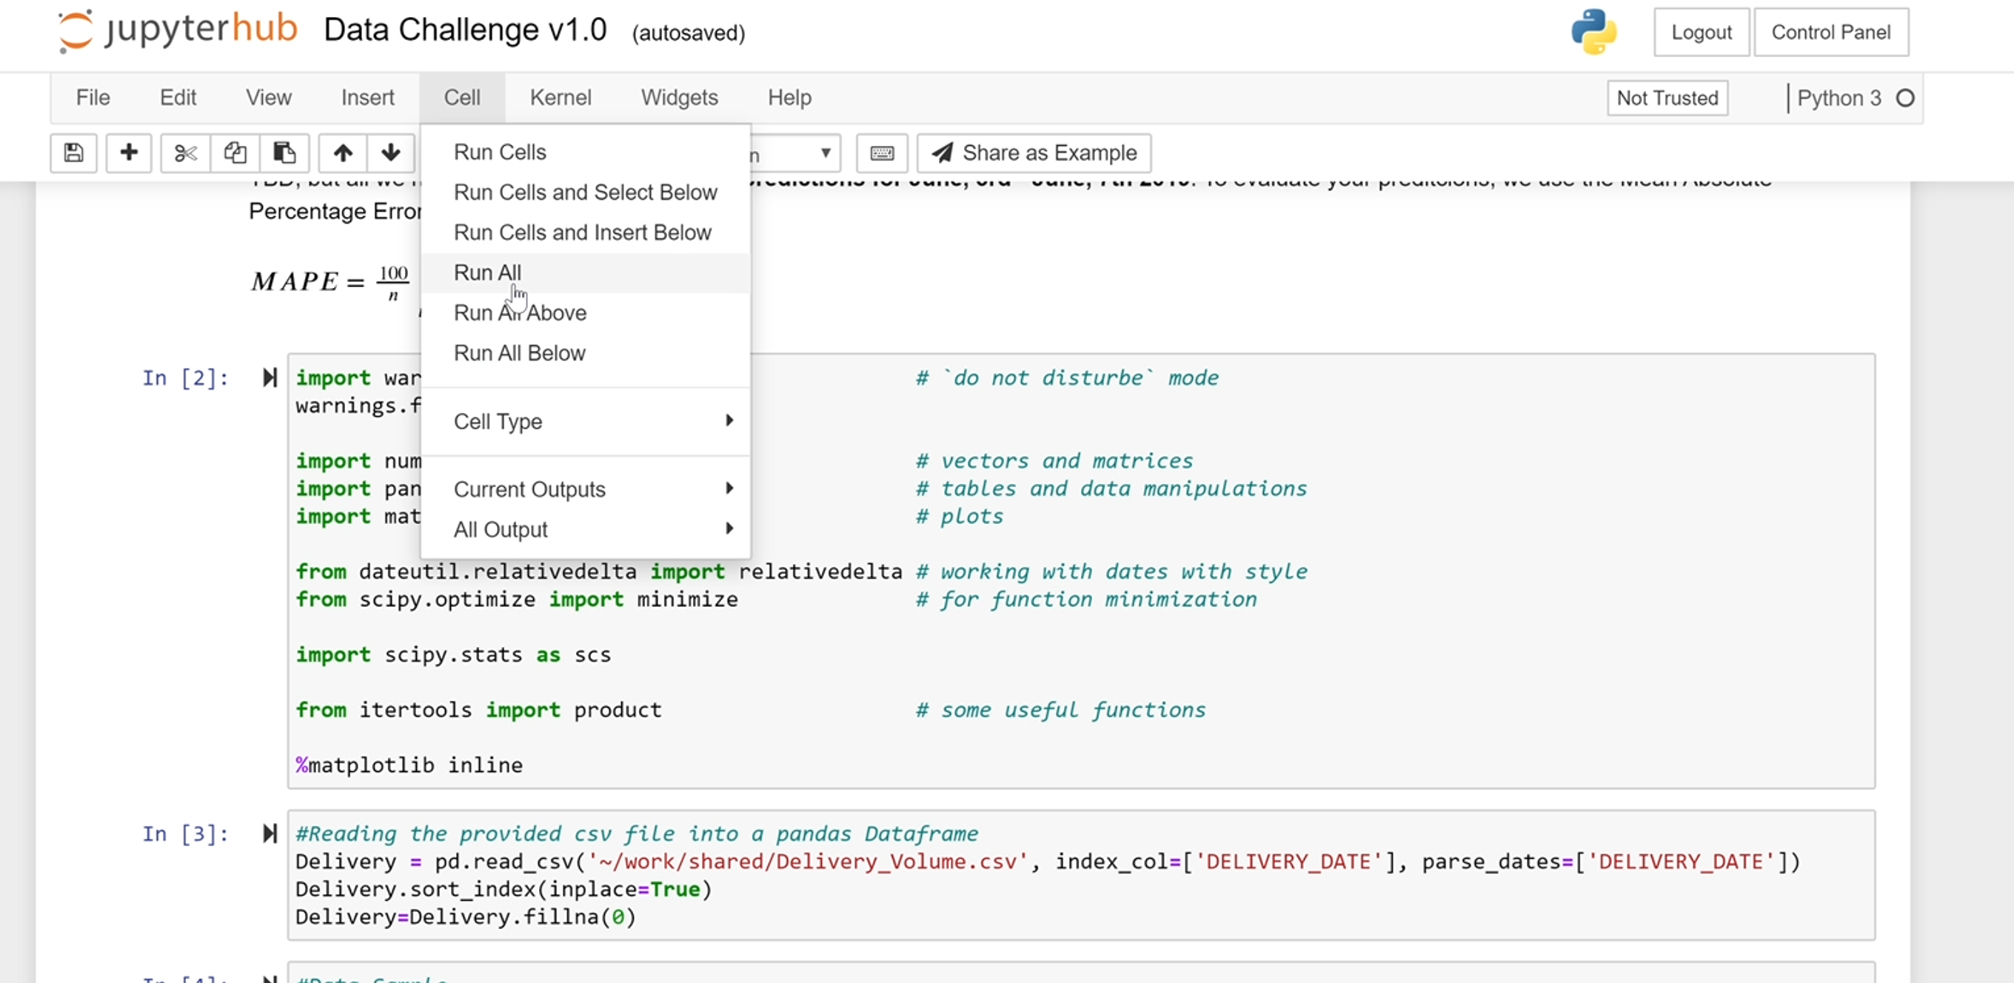
5. Go through the notes provided in the notebook to get a better understanding of the problem statement, the data and how you will be expected to generate the output.
6. Make sure to save your changes to the code regularly   
   